# Developer’s test

## Task 1: Table with random numbers

Make an ASP.NET page that generates a table like the example table 1. This table has 10 rows.

**Table 1: Example**

|  |  |  |  |
| --- | --- | --- | --- |
| **#** | **Random numbers** | **Suma** | **Suma 2** |
| 1 | 1 | 1=1 | 1=1 |
| 2 | 34 | 1+34=35 | 1+ 35=36 |
| 3 | 45 | 1+34+45=80 | 1 +35 + 80 =116 |
| 4 | 565 | 1+34+45+565=645 | 1 +35 + 80 + 645=761 |
| 5 | 456 | 1+34+45+565+456=1101 | 1 +35 + 80 + 1101=1862 |
| … | … | … | … |
| 10 | … | … | … |

Columns of the table:

* Column 1: order numbers of table rows
* Column 2: random numbers in interval from 1 to 1000
* Column 3: sum of numbers from column 1 where order number is less then the order number from current table row. See calculation example in the table 1
* Column 4: sum of numbers from columns 3. See calculation example

The generated table should look like this Example table. The columns 3 and 4 should display the calculation formula and the final sum like it is in the example Table 1.

## Task 2: XML

Make a page that lists data from RSS feed <http://www.rtvslo.si/novice/rss/>

## Task 3: Upload

Make a page with file upload functionality that uploads a file into MS SQL database.

## Task 4: SQL

In Ms SQL DB are three tables that related as shown on picture 1. We have the main table "template" sub table "tamplate_line" and sub - sub table "template_module".

**Picture 1:**

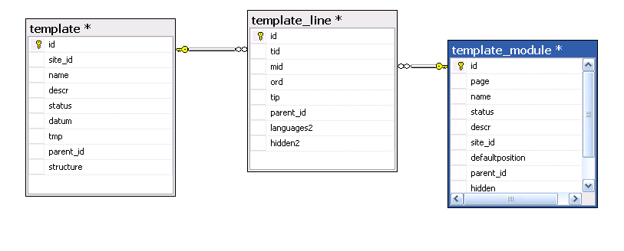  
The object is to write a SQL procedure that would duplicate the complete tree structure of the 3 tables.   
  
For illustration check table 2 with sample data. With yellow color are represented new table lines that were added by this duplicating SQL procedure.

First you will have to duplicate the one line in the "template" table. The field "name" in that duplicated line should have the value "duplicated page". Then you have to duplicate the data from the "Template_line" and "template_modules" table. Every time when you duplicate some data you must correctly fill the parent_id fields. The duplicated lines must have in the parent_id fields the ID of the source line. See example in table 2.

**Table 2: Data duplicating example**

|  |  |  |  |  |  |
| --- | --- | --- | --- | --- | --- |
|  |  |  |  |  |  |
| Table: Tamplate | |  |  |  |  |
| TemplateId | Name | ParentId |  |  |  |
| |  | | --- | | 508 | | page | null |  |  |  |
| 509 | Duplicate page | 508 |  | New record |  |
|  |  |  |  |  |  |
|  |  |  |  |  |  |
|  |  |  |  |  |  |
| Table: Template_line | |  |  |  |  |
| TemplateLineId | TemplateId | TemplateModuleId | ParentId |  |  |
| 3195 | 508 | 48 | null |  |  |
| 3191 | 508 | 50 | null |  |  |
| 3185 | 508 | 51 | null |  |  |
| 3186 | 508 | 52 | null |  |  |
| 3318 | 508 | 63 | null |  |  |
| 3285 | 508 | 66 | null |  |  |
| 3196 | 508 | 124 | null |  |  |
| 3197 | 509 | 125 | 3195 |  |  |
| 3198 | 509 | 126 | 3191 |  |  |
| 3199 | 509 | 127 | 3185 | New records |  |
| |  | | --- | | 3200 | | 509 | 128 | 3186 |  |  |
| 3201 | 509 | 129 | 3318 |  |  |
| 3202 | 509 | 130 | 3285 |  |  |
| 3203 | 509 | 124 | 3196 |  |  |
|  |  |  |  |  |  |
|  |  |  |  |  |  |
|  |  |  |  |  |  |
|  |  |  |  |  |  |
|  |  |  |  |  |  |
|  |  |  |  |  |  |
|  |  |  |  |  |  |
| Table: Template Module | |  |  |  |  |
| TemplateModuleId | Name | ParentId |  |  |  |
| 48 | Left Catalog One Level | null |  |  |  |
| 51 | Header 1 | null |  |  |  |
| 52 | Footer 1 | null |  |  |  |
| 63 | Main Path | null |  |  |  |
| 66 | Right Why TopSHop | null |  |  |  |
| 124 | Main Page | null |  |  |  |
| 125 | Left Catalog One Level | 48 |  |  |  |
| 126 | Header 1 | 51 |  |  |  |
| 127 | Footer 1 | 52 | New records | |  |
| 128 | Main Path | 63 |  |  |  |
| 129 | Right Why TopSHop | 66 |  |  |  |
| 130 | Main Page | 124 |  |  |  |
|  |  |  |  |  |  |
|  |  |  |  |  |  |
|  |  |  |  |  |  |